tel  mobile  e-mail  website | +27 (0) 12 665 0937  +27 (0) 82 457 0532  admin@macmillanfoundation.co.za  www.snapp.org.za | 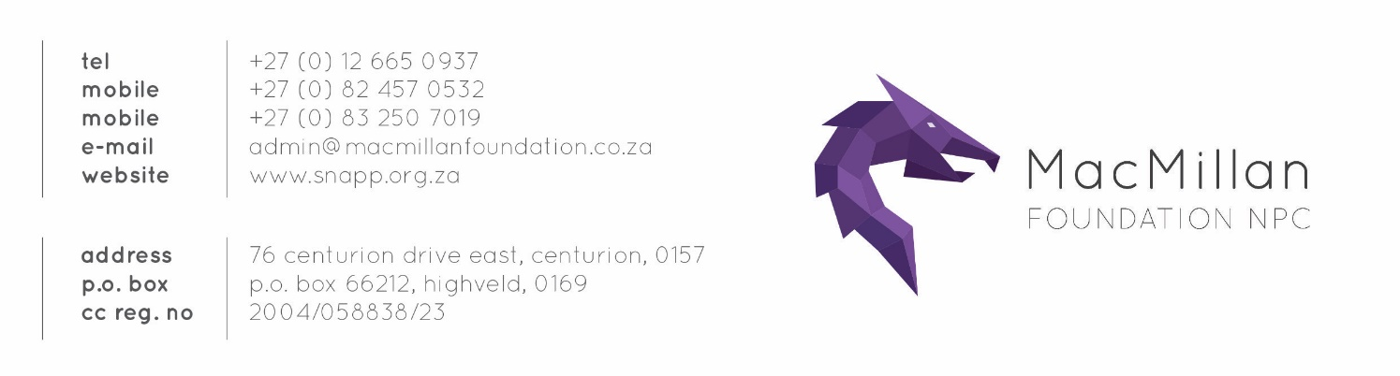
address  p.o. address  co. reg. no | 76 centurion drive east, centurion, 0157  p.o. box 66212, highveld, 0169  2017/297773/08

MacMillan Foundation Bursary
2025 2026

ABOUT THE COMPANY - MACMILLAN FOUNDATION NPC

The MacMillan Foundation NPC was founded by SNAPP Architects (Pty) Ltd in order to further the aspirations of previously disadvantaged women, below thirty-five years of age, for post graduate studies in the field of architecture. For more information on the MacMillan Foundation click on the below: https://snapp.org.za/macmillan-foundation.

ABOUT THE BURSARY PROGRAMME

The MacMillan Foundation Bursary was created to assist students with strong academic merit, but lacking financial means. The bursary will be awarded to students who are currently studying or intend studying towards the attainment of a Post Graduate Degree in Architecture.

PAYMENT OF BURSARY

The Foundation will pay the bursary amount directly into the recipient’s account at the respective academic institution. Payment will only be made on presentation of proof of registration and a Tax Invoice from the academic institution. The bursary is limited to one year of study and restricted to the allocated amount.

ELIGIBILITY REQUIREMENTS
Applicants must satisfy the following minimum entry criteria before applying:
- Must be a South African citizen
- Must be black as defined in RSA B-BBEE Codes
- Must be female
- Must complete the degree before attaining thirty-five years of age
- Must be currently studying or intending studying towards the attainment of a Post Graduate Degree in Architecture
- Must enrol in an accredited university in the Republic of South Africa
- Must provide proof of their current accounts with the respective university (indicate if it is paid up in full or still outstanding)
- Must have strong academic record
- Must have no previous criminal record

GATHERING OF PERSONAL INFORMATION (POPI Act)

MacMillan Foundation NPC is gathering your personal information for evaluation of the 2024/2025 MacMillan Foundation NPC bursary purposes only. Your information will be kept safe and processed in a responsible manner. By signing this agreement, you approve to these conditions.

HOW TO APPLY FOR THE BURSARY

- Download and complete the MacMillan Foundation Bursary Form in either of the following formats, obtainable on request, from the E-mail address below:

MacMillan Foundation Bursary Form(.pdf) MacMillan Foundation Bursary Form(.doc)

- Submit clear copies of the following supporting documentation with your application form (Max 10MB)

Certified Copy of South African Identification Document
Latest Academic Results
Letter of recommendation from one of your lecturers
Declaration of outstanding debt towards previous studies
Declaration or Affidavit indicating financial independence from parents (if applicable)
Any additional supporting documentation (e.g. CV, portfolio)

- Applications are to be submitted electronically
E-mail: admin@macmillanfoundation.co.za

Closing date:
04 November 2025

Award date:
02 December 2025

BURSARY CONDITIONAL ACCEPTANCE, PENDING:
• Final Results
• University Document Confirming Tuition Fees

SUCESSFUL APPLICANTS WILL BE REQUIRED TO ENTER INTO A BURSARY AGREEMENT WITH THE MACMILLAN FOUNDATION NPC IN ORDER TO PARTICIPATE IN THE SCHEME. THERE WILL BE NO WORK-BACK OBLIGATION IN RETURN FOR THE AWARD.

MacMillan Foundation NPC
Bursary Application Form

APPLICATION FOR:

YES / NO | BURSARY TYPE | PROVIDE BRIEF DESCRIPTION
Current Studies
(Please provide University document confirming amount, full course name & institution you wish to attend)

Future Studies
(Please provide University document confirming amount, full course name & institution you wish to attend)

Study Fees in Arrears
(Please provide University document confirming amount & include proof with your application)

Other
(Please provide description, indicate amount & include document proof with your application)

PERSONAL INFORMATION
Names |  | Tel No.
Surname |  | Cell No.
ID No. |  | E-mail
Gender |  | Marital status
Ethnicity |  | Dependants
Income of applicant (If any)
Domicillium / Physical Address |  | Postal address
Are you financially dependent on a parent/guardian? |  |  | Yes |  | No
Are you currently employed and earning a salary? |  |  | Yes |  | No

FIRST PARENT/GUARDIAN INFORMATION
Names |  | Tel No.
Surname |  | Cell No.
ID No. |  | E-mail
Gender |  | Marital status
Ethnicity |  | Dependants
Occupation |  | Income per month
Domicillium / Physical Address |  | Postal address

SECOND PARENT/GUARDIAN INFORMATION
Names |  | Tel No.
Surname |  | Cell No.
ID No. |  | E-mail
Gender |  | Marital status
Ethnicity |  | Dependants
Occupation |  | Income per month
Domicillium / Physical Address |  | Postal address

STUDY DETAILS
Institution
Accredited Y/N
Duration
Estimated cost
Admission Status
Please attach course details and quotation from chosen institution

SECONDARY EDUCATION
Year Grade 12 was completed
Name of Institution
Address of Institution
Tel. No.
TERTIARY EDUCATION
Studying at present? Y/N
Institution
Course
Student No.
Course completion date
Bursaries in the past? Y/N
If yes, from whom?
Bursary at present? Y/N
Dissertation if applicable

ADDITIONAL TERTIARY EDUCATION
Institution
Course
Student No.
Completion date
ADDITIONAL TERTIARY EDUCATION
Institution
Course
Student No.
Completion date

CURRENT ACADEMIC RECORD
Dissertation
Subjects | June results | Final results
1
2
3
4
5
6
7
8
9
10
11
12
13
14
15
Please attach certified copies of all results & transcripts

EXTRAMURAL ACTIVITIES AND INTERESTS
1
2
3
4
5
6
7
8
9
10
11
12
13
14
15

ACHIEVEMENTS
1
2
3
4
5
6
7
8
9
10
11
12
CAREER CHOICE
( Briefly describe reasons)

WORK EXPERIENCE / VACATION WORK / PRACTICAL EXPERIENCE
Dates | Employer | Duties

CONSTRUCTION SITE EXPERIENCE
Dates | Site | Impression

DECLARATION
I, (Full names)
hereby certify that the information provided on this application form is correct and complete.
Signature:……………………………………… Date:…………………………………

DOCUMENTATION CHECKLIST
No. | Description | Yes/No
1. | Read and understand Eligibility Requirements
2. | Certified copy of South African identification document
3. | Latest academic results
4. | Letter of recommendation from one of your lecturers
5. | Declaration of outstanding debt towards previous studies
6. | Declaration or Affidavit indicating financial independence from parents (if applicable)
7. | Additional supporting documentation (CV, portfolio etc.)
8. | Bursary for  - Current Studies  (Please provide University document confirming amount, full course name & institution you wish to attend)  - Future Studies  (Please provide University document confirming amount, full course name & institution you wish to attend)  - Study Fees in Arrears  (Please provide University document confirming amount & include proof with your application)  - Other  (Please provide description, indicate amount & include document proof with your application)
9. | Fully completed & signed Bursary Application Form

